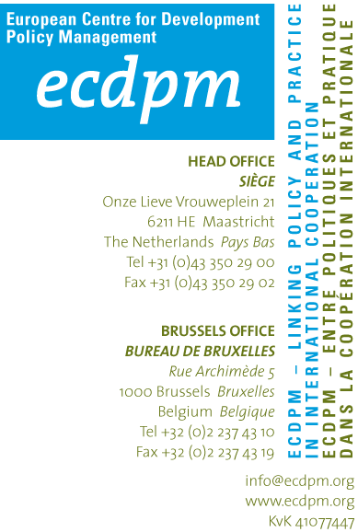

Confidential Application Form

please return to: Mr Guy Janssen – gj@ecdpm.org

Position applied for: YIP ACD-CEMI

Surname

First name

Nationality

Date and place of birth and gender (M/F)

Full Address & (private) e-mail address  (where normally contactable) |  |  | Private Telephone  (and times when normally available)  No: +  Times: |  | Work Telephone  (and times available if we may contact you)  No: +  Times
Available as of: …../…… / ……

EMPLOYMENT
Please start with your present/last employment and work backwards
From | To | Employer’s Name & Address | Job Title & main responsibilities
Total amount of years of relevant working experience:
Total amount of years in developing countries:

EDUCATION
Name & address of schools/ colleges/universities attended since pre-university to present, starting with most recent  (state if full or part-time) | Dates attended |  | Qualifications & grades obtained  (i.e. Bachelor, MSc, MBA, Professional qualifications etc)
 | From | To

JOB-RELATED AREAS OF EXPERTISE DESCRIBE THE MATCH
Master’s degree in International relations, political science or political economy;
1-2 years of experience working on/in North Africa on governance issues;
Good understanding of the change dynamics in North Africa and related work experience in at least 1 North African country
Excellent writing, editing, analytical and synthesis skills, including the ability to structure arguments and present options to policy makers in a non-partisan way). Kindly include links to any published material in the box below;
Excellent command of English;
Good command of Arabic;
Good working knowledge of French;
Exposure to the donor landscape in North African countries;
Self-steering and entrepreneurial (give a brief example);
Networking skills;

LISTING OF PUBLICATIONS AND REPORTS
(with full references and hyperlinks where available)
Please list the publications, papers and reports you have written or co-authored

LANGUAGE SKILLS
Please use the CEFR guideline to describe your knowledge and understanding of foreign languages (Basic A1/A2 – Independent B1/B2 – Proficient C1/C2)

Mother tongue
 |  | Understanding |  | Speaking |  | Writing
 |  | Listening | Reading | Spoken interaction | Spoken production
English
Arabic
French
Other languages

REFERENCES
Please give details below of three people whom we may contact for references. References will be taken up if you are short listed unless you specify otherwise. Your referees should have knowledge of you in a working environment, either paid or unpaid, preferably one should be your current / last employer.

Previous surname (if necessary) for reference purposes:

For office use only  Taken up Received |  | Name | Occupation/ Job Title | Full Address | E/mail address

MOTIVATION IN SUPPORT OF YOUR APPLICATION
In the space below, please give a brief statement in support of your application giving your reasons for applying.

APPLICATION HISTORY
Have you previously applied for a position at ECDPM?
O Yes
Position
Programme
Date
O No

Have you completed ECDPM’s online open application form?
O Yes
O No

VACANCY
Please inform us where you found the vacancy
O Own network (please specify if introduced through an individual ________________________
O Website ECDPM
O Other (please complete)

DECLARATION
I certify that all particulars given are correct and understand that should any false statement(s), omission(s) be made on this form ECDPM reserves the right of dismissal. I understand that employment with ECDPM is subject to receipt of satisfactory references.

Signature of applicant is ascertained through sending this document by e-mail.

Please return this application form to the address stated on the top of the front page of this form.

